**The Smart Home Automation System**

**(CQI – Activity)**

|  |  |  |
| --- | --- | --- |
| **Name** | **Enrollment** | **Reg No** |
| **Hira Faisal** | **02-131222-106** | **81967** |
| **Hamza Faisal** | **02-131222-066** | **81939** |
| **Jawad Ahmed** | **02-131222-094** | **81958** |

**TASK:**

* **Project Definition:**

The Smart Home System project aims to solve the problem of fragmented and inefficient control of smart home devices. Currently, users must rely on multiple disconnected applications to manage lighting, security, appliances, and environmental settings, which leads to confusion, inconvenience, and security risks. This project proposes the development of a centralized, user-friendly digital platform accessible via mobile and web that allows homeowners to control and monitor all smart devices in one place. The system will support automation, real-time alerts, and role-based access, ultimately enhancing home security, comfort, and energy efficiency.

* **Vision Statement:**

***For*** homeowners ***who*** need a convenient and secure way to manage and monitor their household devices, ***the*** Smart Home System ***is*** a digital platform ***that*** helps them control lighting, temperature, security, and appliances from anywhere at any time. With an intuitive mobile and web dashboard, users can automate tasks like locking doors, switching off unused lights, or setting thermostat schedules. ***Unlike*** traditional systems where devices are controlled manually or separately, ***our produc***t integrates everything in a unified, smart, and user-friendly interface that responds to users' lifestyles and preferences.

* **Functional Requirement:**

**User Registration and Login**

Users can sign up and log in securely to access the system. Role-based access allows different features for Admins, Guests, and Family Members.

**Device Management**

Users can add, remove, or group smart devices easily. Devices can also be assigned to specific rooms or zones for better organization.

**Remote Control**

Users can control home devices remotely through the app. This includes turning ON/OFF lights, adjusting thermostats, and locking or unlocking doors.

**Automation Rules**

Users can create custom rules like turning off lights at a certain time. The system can also trigger actions based on events, such as sending alerts if motion is detected.

**Live Monitoring**

Users can watch live video feeds from security cameras. Alerts are also sent if smoke, gas, or movement is detected inside the home.

**Notifications and Alerts**

The system sends instant alerts via push, SMS, or email. These notifications cover emergencies, security issues, or device malfunctions.

**Energy Monitoring (Integration with K-Electric)**

Users can see how much energy their devices are using. The system also gives tips to save energy and lower bills.

**Multilingual Support**

The platform should support multiple languages like English and Urdu. This helps users from different backgrounds use the system in their preferred language.

* **Non-Functional Requirement:**

### Performance

The system should handle user commands like turning on lights or locking doors within 2 seconds. Fast response ensures smooth user experience and real-time control.

### Reliability

The system should offer 99.9% uptime for cloud services. This ensures users can access and control their home devices almost anytime without interruption.

### Security

All data and communication must be encrypted using HTTPS and SSL. The system should also use two-factor authentication and role-based access to protect user accounts.

### Scalability

The platform should support up to 100 smart devices in a single home. This ensures the system can grow with user needs over time.

### Maintainability

The system should have modular and well-organized code. This makes it easy to fix bugs, add features, and update the software regularly.

### Usability

The app should have a clean, simple design with clear instructions. Tutorials and tooltips should help users understand how to use every feature.

### Accessibility

The system should include features like larger text, voice support, and easy navigation. This makes it easier for elderly or disabled users to use the platform.

### Portability

The system must work across Android, iOS, and web browsers. This allows users to control their home from any device they prefer.

* **Low Fidelity:**

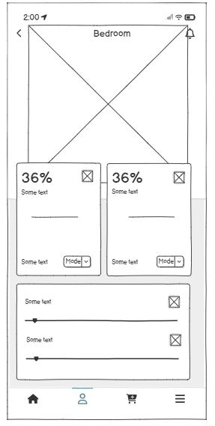 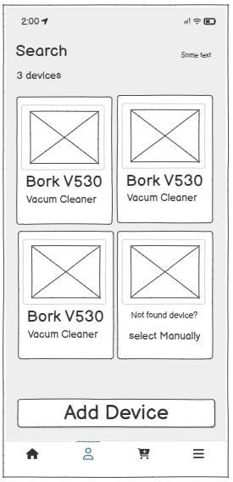

* **High Fidelity:**

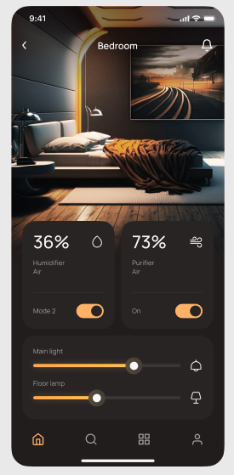 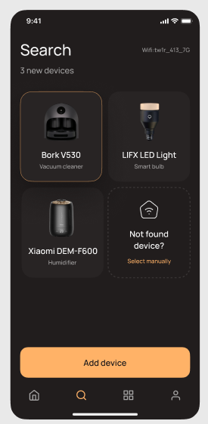

* **UML Diagrams:**

